**WITH NOISE AND WITHOUT FILTER FUZZY**

**Image set:**

|  |
| --- |
| **Image 1:-0.1 % Noise** |

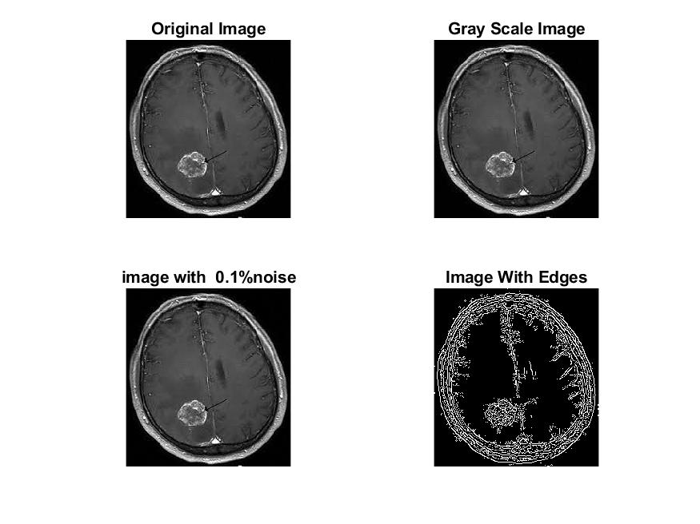

**Image 2:-10 % Noise**

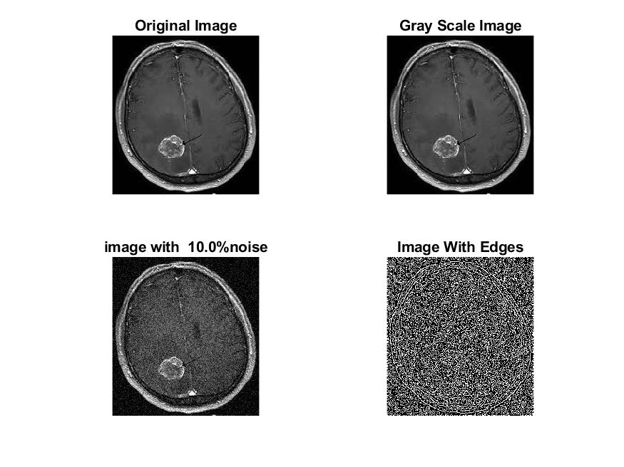

**Image 3:-20 % Noise**

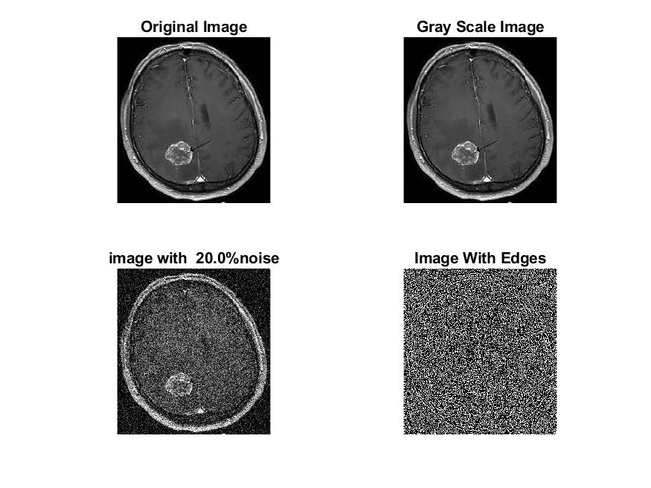

**Image 4:-30 % Noise**

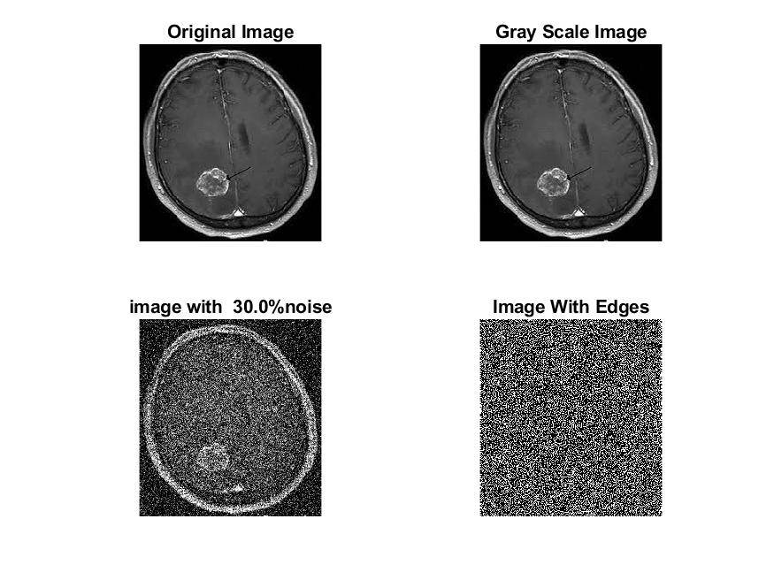

|  |
| --- |
| **Image 5:-40 % Noise** |

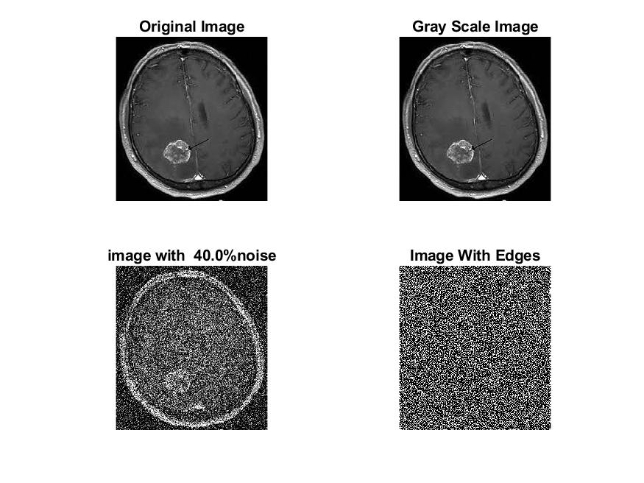

**Image 6:-50 % Noise**

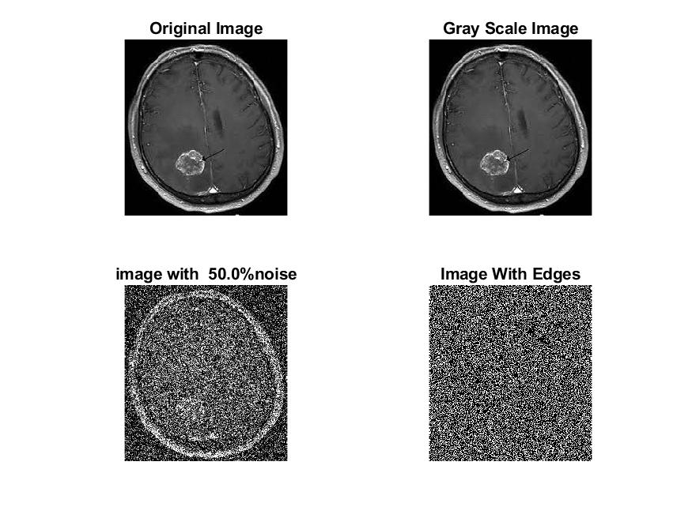

**Image 7:-60 % Noise**

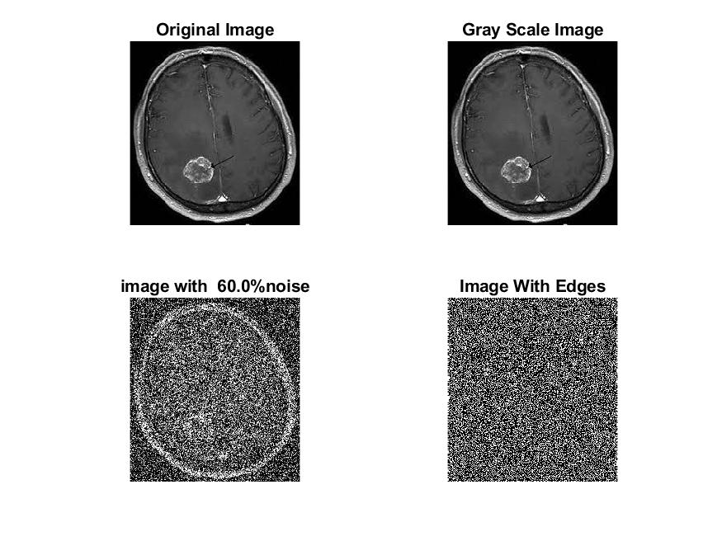

**Image 8:-70 % Noise**

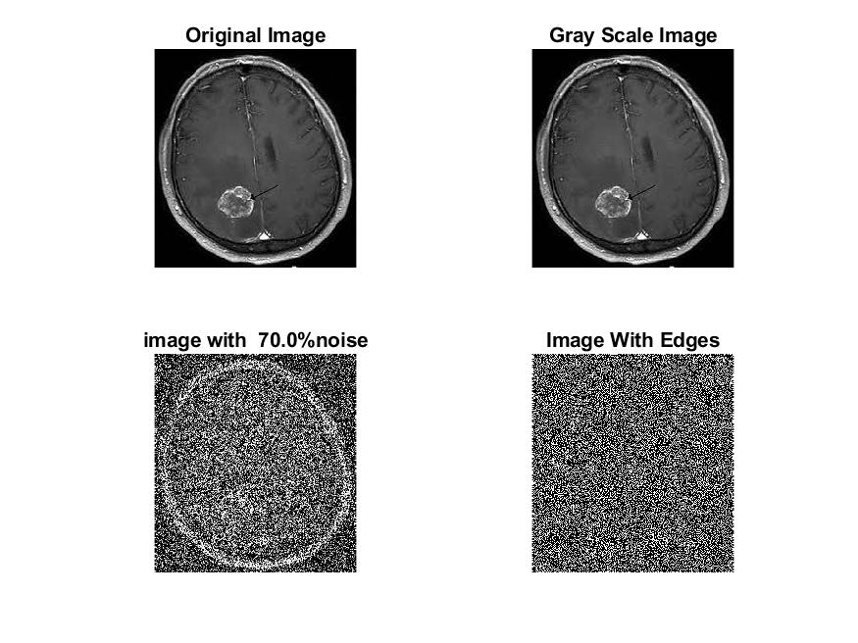

**Image 9:-80 % Noise**

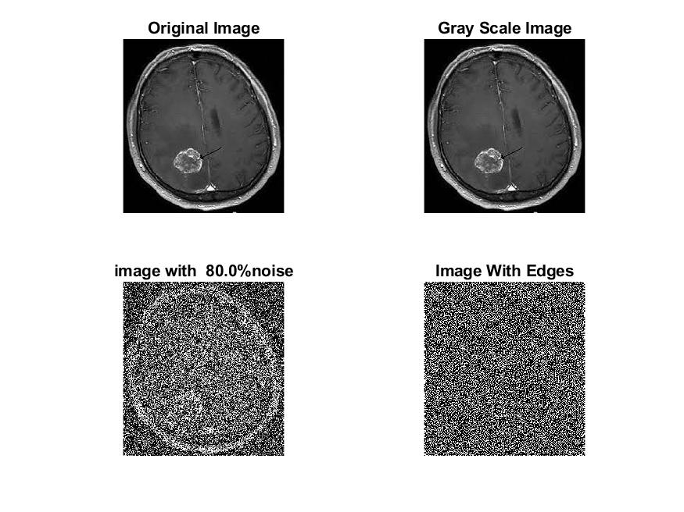

**DATA FILES**

**Image 1:-Noise0.1**

Original image ideal values:

IM1 image entropy:5.758271e-01

IM1 image mean:0.136811

Ground truth image entropy:0.746959

Ground truth image mean:0.212884

entropy between imt and im1 :0.645918

MSE between imt and im1 :0.253739

Average Difference between imt and im1 :0.076072

Maximum Difference between imt and im1 :1.000000

True Positive values:2425.000000

False Positive values: 4490.000000

True Negative values:35294.000000

False Negative values:8335.000000

Accuracy value: 0.746261

F Measure values:0.274399

Peak Signal-to Noise Ration value: 5.956122

Signal-to Noise Ration value: -1.920201

percentage of pixels that were correctly detected (Pco): 0.225372

The percentage of pixels that were not detected (Pnd):0.774628

the percentage of false alarm: (Pfa):0.417286

Euclidean Distance Value :21.571072

**Image 2:-Noise10**

Original image ideal values:

IM1 image entropy:9.185726e-01

IM1 image mean:0.333610

Ground truth image entropy:0.746959

Ground truth image mean:0.212884

entropy between imt and im1 :0.600373

MSE between imt and im1 :0.413224

Average Difference between imt and im1 :-0.120726

Maximum Difference between imt and im1 :1.000000

True Positive values:3368.000000

False Positive values: 13494.000000

True Negative values:26290.000000

False Negative values:7392.000000

Accuracy value: 0.586776

F Measure values:0.243864

Peak Signal-to Noise Ration value: 3.838143

Signal-to Noise Ration value: 1.950968

percentage of pixels that were correctly detected (Pco): 0.199739

The percentage of pixels that were not detected (Pnd):0.438382

the percentage of false alarm: (Pfa):0.800261

Euclidean Distance Value :19.018063

**Image 3:-Noise20**

Original image ideal values:

IM1 image entropy:9.239078e-01

IM1 image mean:0.339051

Ground truth image entropy:0.746959

Ground truth image mean:0.212884

entropy between imt and im1 :0.592972

MSE between imt and im1 :0.412888

Average Difference between imt and im1 :-0.126167

Maximum Difference between imt and im1 :1.000000

True Positive values:3514.000000

False Positive values: 13623.000000

True Negative values:26161.000000

False Negative values:7246.000000

Accuracy value: 0.587112

F Measure values:0.251927

Peak Signal-to Noise Ration value: 3.841680

Signal-to Noise Ration value: 2.021225

percentage of pixels that were correctly detected (Pco): 0.205053

The percentage of pixels that were not detected (Pnd):0.422828

the percentage of false alarm: (Pfa):0.794947

Euclidean Distance Value :19.547580

**Image 4:-Noise30**

Original image ideal values:

IM1 image entropy:9.227024e-01

IM1 image mean:0.337805

Ground truth image entropy:0.746959

Ground truth image mean:0.212884

entropy between imt and im1 :0.588567

MSE between imt and im1 :0.408238

Average Difference between imt and im1 :-0.124921

Maximum Difference between imt and im1 :1.000000

True Positive values:3600.000000

False Positive values: 13474.000000

True Negative values:26310.000000

False Negative values:7160.000000

Accuracy value: 0.591762

F Measure values:0.258676

Peak Signal-to Noise Ration value: 3.890862

Signal-to Noise Ration value: 2.005230

percentage of pixels that were correctly detected (Pco): 0.210847

The percentage of pixels that were not detected (Pnd):0.419351

the percentage of false alarm: (Pfa):0.789153

Euclidean Distance Value :20.125359

**Image 5:-Noise40**

Original image ideal values:

IM1 image entropy:9.240221e-01

IM1 image mean:0.339170

Ground truth image entropy:0.746959

Ground truth image mean:0.212884

entropy between imt and im1 :0.592921

MSE between imt and im1 :0.412967

Average Difference between imt and im1 :-0.126286

Maximum Difference between imt and im1 :1.000000

True Positive values:3515.000000

False Positive values: 13628.000000

True Negative values:26156.000000

False Negative values:7245.000000

Accuracy value: 0.587033

F Measure values:0.251944

Peak Signal-to Noise Ration value: 3.840847

Signal-to Noise Ration value: 2.022746

percentage of pixels that were correctly detected (Pco): 0.205040

The percentage of pixels that were not detected (Pnd):0.422621

the percentage of false alarm: (Pfa):0.794960

Euclidean Distance Value :19.546234

**Image 6:-Noise50**

Original image ideal values:

IM1 image entropy:9.250654e-01

IM1 image mean:0.340258

Ground truth image entropy:0.746959

Ground truth image mean:0.212884

entropy between imt and im1 :0.586867

MSE between imt and im1 :0.409386

Average Difference between imt and im1 :-0.127374

Maximum Difference between imt and im1 :1.000000

True Positive values:3633.000000

False Positive values: 13565.000000

True Negative values:26219.000000

False Negative values:7127.000000

Accuracy value: 0.590614

F Measure values:0.259890

Peak Signal-to Noise Ration value: 3.878671

Signal-to Noise Ration value: 2.036657

percentage of pixels that were correctly detected (Pco): 0.211245

The percentage of pixels that were not detected (Pnd):0.414409

the percentage of false alarm: (Pfa):0.788755

Euclidean Distance Value :20.164976

**Image 7:-Noise60**

Original image ideal values:

IM1 image entropy:9.258382e-01

IM1 image mean:0.341069

Ground truth image entropy:0.746959

Ground truth image mean:0.212884

entropy between imt and im1 :0.588104

MSE between imt and im1 :0.411147

Average Difference between imt and im1 :-0.128185

Maximum Difference between imt and im1 :1.000000

True Positive values:3609.000000

False Positive values: 13630.000000

True Negative values:26154.000000

False Negative values:7151.000000

Accuracy value: 0.588853

F Measure values:0.257795

Peak Signal-to Noise Ration value: 3.860032

Signal-to Noise Ration value: 2.046998

percentage of pixels that were correctly detected (Pco): 0.209351

The percentage of pixels that were not detected (Pnd):0.414815

the percentage of false alarm: (Pfa):0.790649

Euclidean Distance Value :19.975995

**Image 8:-Noise70**

Original image ideal values:

IM1 image entropy:9.305680e-01

IM1 image mean:0.346134

Ground truth image entropy:0.746959

Ground truth image mean:0.212884

entropy between imt and im1 :0.583608

MSE between imt and im1 :0.412769

Average Difference between imt and im1 :-0.133250

Maximum Difference between imt and im1 :1.000000

True Positive values:3696.000000

False Positive values: 13799.000000

True Negative values:25985.000000

False Negative values:7064.000000

Accuracy value: 0.587231

F Measure values:0.261617

Peak Signal-to Noise Ration value: 3.842929

Signal-to Noise Ration value: 2.111017

percentage of pixels that were correctly detected (Pco): 0.211260

The percentage of pixels that were not detected (Pnd):0.403773

the percentage of false alarm: (Pfa):0.788740

Euclidean Distance Value :20.166154

**Image 9:-Noise80**

Original image ideal values:

IM1 image entropy:9.295107e-01

IM1 image mean:0.344987

Ground truth image entropy:0.746959

Ground truth image mean:0.212884

entropy between imt and im1 :0.584645

MSE between imt and im1 :0.412413

Average Difference between imt and im1 :-0.132103

Maximum Difference between imt and im1 :1.000000

True Positive values:3676.000000

False Positive values: 13761.000000

True Negative values:26023.000000

False Negative values:7084.000000

Accuracy value: 0.587587

F Measure values:0.260737

Peak Signal-to Noise Ration value: 3.846677

Signal-to Noise Ration value: 2.096595

percentage of pixels that were correctly detected (Pco): 0.210816

The percentage of pixels that were not detected (Pnd):0.406263

the percentage of false alarm: (Pfa):0.789184

Euclidean Distance Value :20.121905